**TABLE OF CONTENTS**

|  |  |
| --- | --- |
| **PARTICULARS** | **PAGE NO** |
| PMCI Analysis | 2-3 |
| Introduction | 3 |
| Product | 3-6 |
| Market | 6-8 |
| Company | 8-10 |
| Industry | 10 |
| SWOT Analysis | 10-12 |
| Product Mix | 12-13 |
| Trends | 14-16 |
| Conclusion | 16-17 |
| References | 17 |

**PRODUCT**

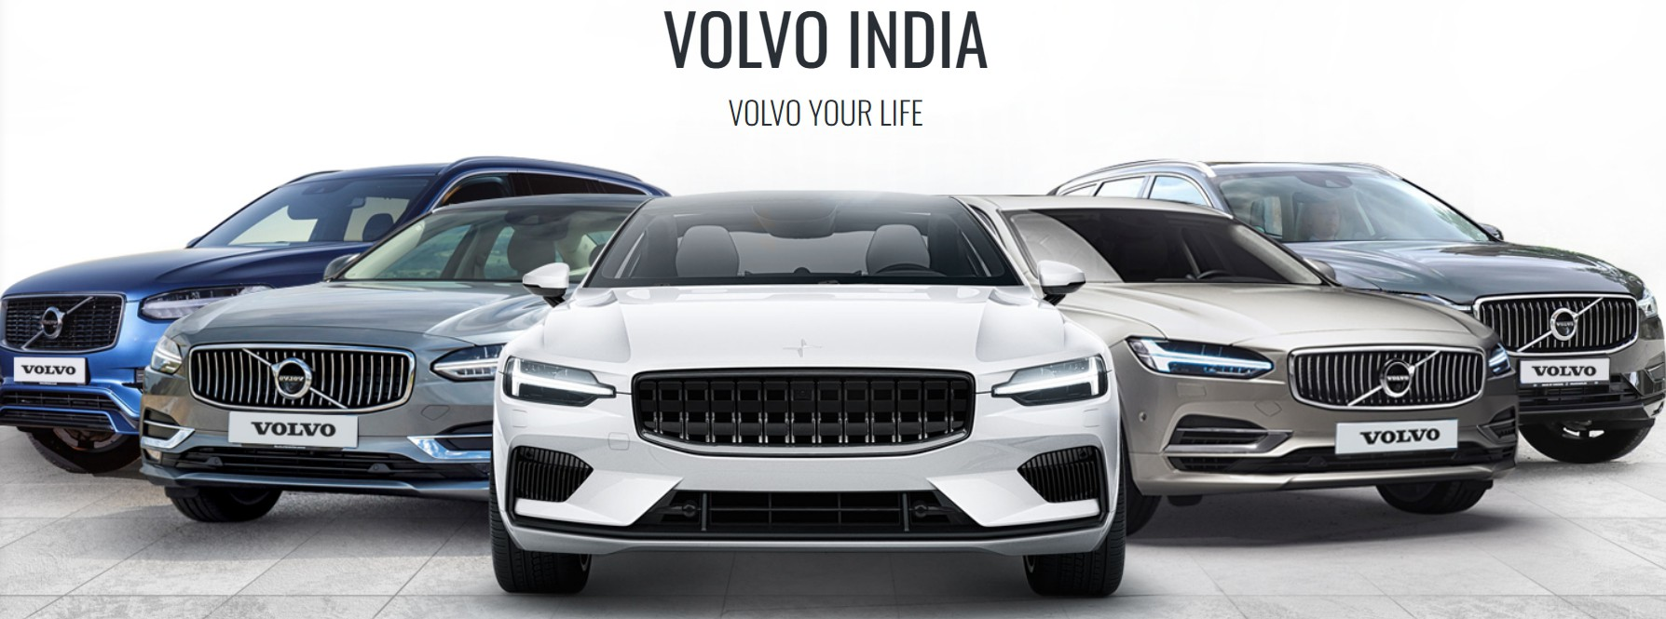

**PMCI ANALYSIS**

Product Market Company Industry Analysis is a comprehensive evaluation method used to understand the competitive positioning and potential success of a business or product within its industry. This analysis focuses on four key components:

1. **Product Analysis**: Examines the specific product or service offered, its features, uniqueness, quality, and how it meets consumer needs. This includes understanding the product's competitive advantages and market fit.

2. **Market Analysis:** Involves assessing the target market, including customer demographics, preferences, and trends. It also looks at the market size, growth potential, and any external factors affecting demand.

3. **Company Analysis:** Focuses on the internal strengths and weaknesses of the company, including financial health, management capabilities, resources, and overall business strategy. This helps to assess whether the company is well-positioned to compete effectively.

4. **Industry Analysis**: Evaluates the broader industry in which the company operates, considering competition, market structure, regulations, and trends. This includes analyzing key competitors, entry barriers, and the overall health of the industry.

Together, these analyses provide a well-rounded view of a product's potential for success and the company's ability to sustain its competitive position within its industry.

**INTRODUCTION**

Volvo Cars, a renowned Swedish automotive brand, is celebrated for its commitment to safety, innovation, and sustainability. Established in 1927, the company has built a legacy of producing vehicles that prioritize passenger protection, becoming a leader in automotive safety technologies. Volvo’s dedication to cutting-edge design and engineering has made it a global name, known for combining luxury with practicality and durability.

In recent years, Volvo has embraced the shift toward electrification and sustainability, aiming to become a fully electric car brand by 2030. Their efforts to reduce carbon emissions and promote environmentally friendly driving align with a growing consumer demand for greener vehicles. This forward-thinking approach places Volvo at the forefront of the automotive industry's future.

**FEATURES**

Volvo Cars are known for a range of standout features that emphasize safety, comfort, and advanced technology:

1. **Safety Innovations**: Volvo leads the industry in safety, with features like City Safety, which detects pedestrians, cyclists, and large animals, and Pilot Assist, a semi-autonomous driving system. Volvo’s IntelliSafe suite offers advanced driver-assistance systems (ADAS), such as lane-keeping aid, collision mitigation support, and automatic braking.

2. **Sustainability and Electrification**: Volvo is focused on becoming an all-electric brand by 2030. Their Recharge lineup features plug-in hybrid and fully electric models, with advanced battery technology for longer range and fast charging capabilities.

3. **Scandinavian Design**: Known for minimalist and elegant design, Volvo interiors emphasize comfort and ergonomics. High-quality materials, like sustainably sourced leather and wood, offer a luxury feel, while the intuitive Sensus infotainment system integrates with Google Assistant and Apple CarPlay.

4. **Performance and Efficiency**: Volvo cars are equipped with powerful yet efficient engines, including the latest plug-in hybrid and electric motors. The T8 Twin Engine, for instance, delivers both high performance and lower emissions.

5. **Advanced Connectivity**: Volvo models feature advanced connectivity options, including integrated navigation systems, over-the-air software updates, and the Volvo On Call app, which provides remote vehicle access and emergency services.

These features combine to create a driving experience that is safe, luxurious, and environmentally conscious.

**SPECIALITIES OF VOLVO CARS**

**World-Leading Safety:** Famous for creating the safest cars with advanced safety features.

**Innovative Technology** : Always coming up with new technology to make driving easier and safer.

**Scandinavian Design**: Known for clean, simple, and elegant car designs.

**Eco-Friendly Focus**: Committed to becoming fully electric by 2030 and reducing environmental impact.

**Comfortable Interiors**: Offers luxurious and comfortable interiors for a smooth driving experience.

**Strong Reputation**: Trusted for making reliable, high- quality cars for many decades.

**VARIANTS**

1. **‘X’SERIES**
2. XC60
3. XC90
4. XC40

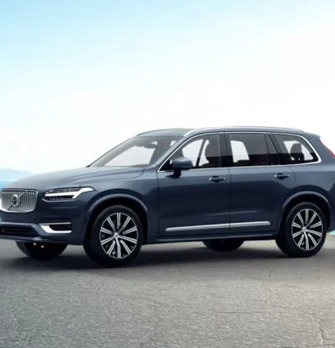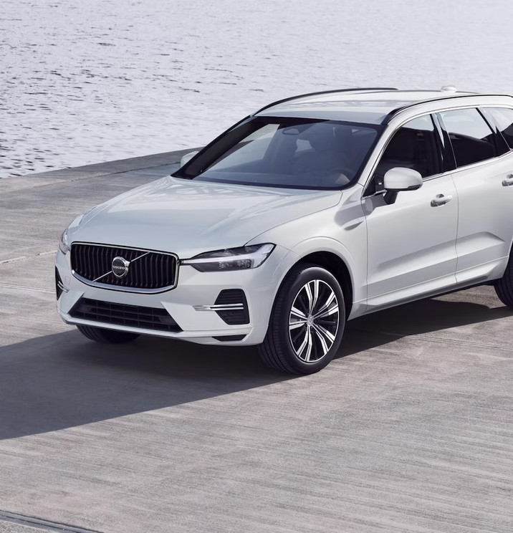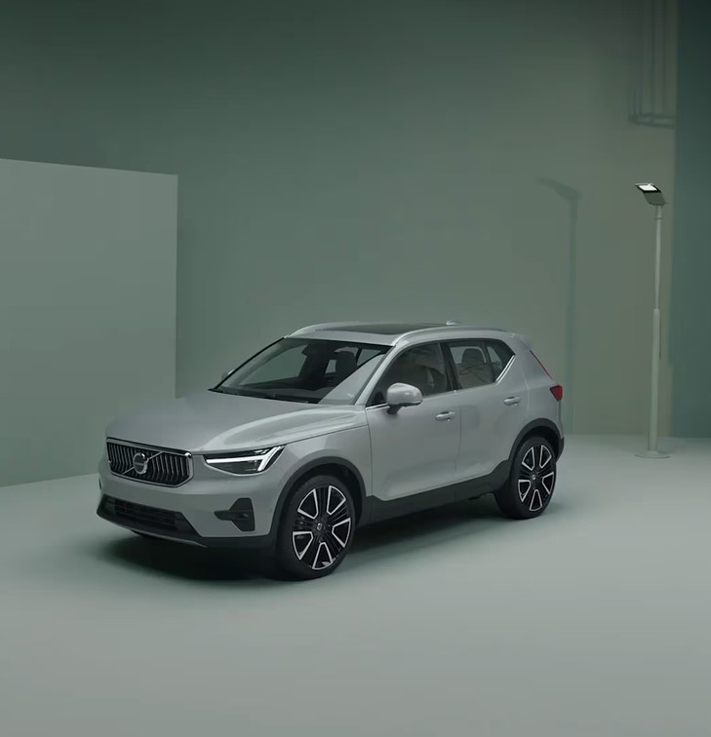

2.**’S’ SERIES**

a. S90

b.S60

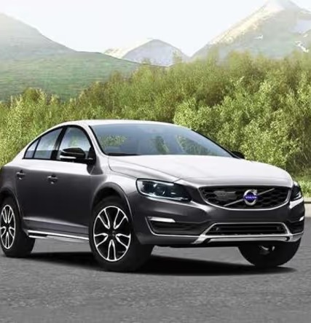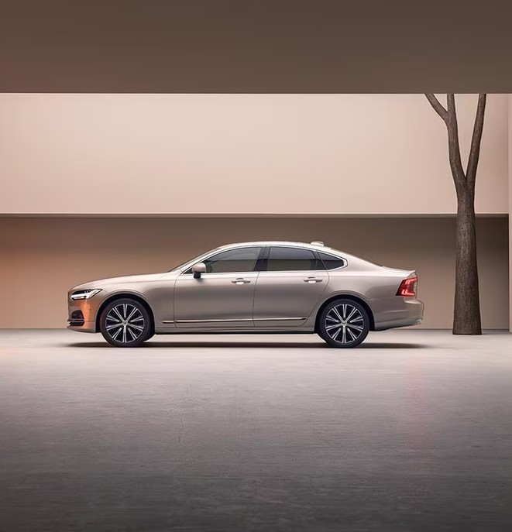

3.**’V’ SERIES**

a. V90

b. V60

c. V40

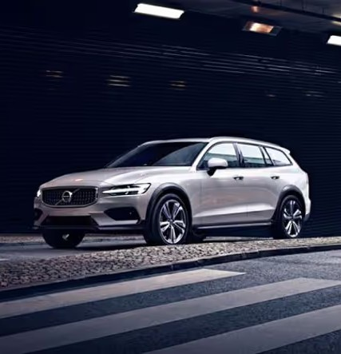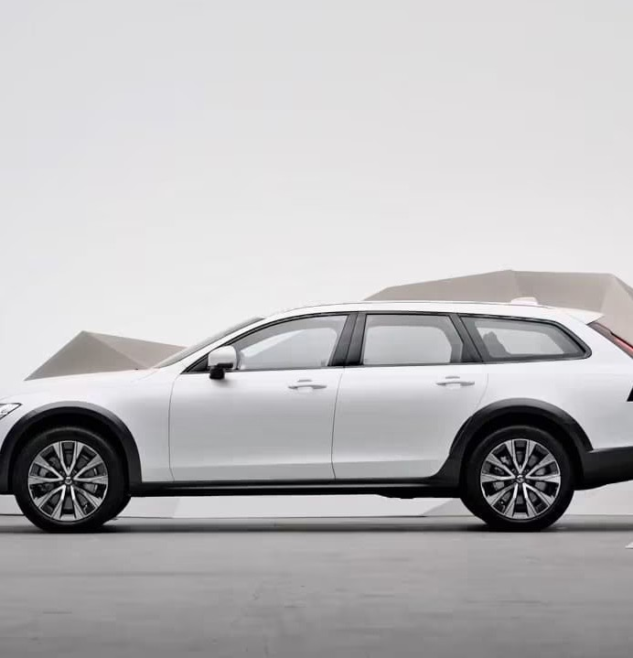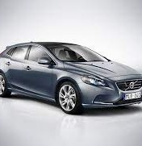

**MARKET ANALYSIS**

**MARKET STRUCTURE**

**Oligopolistic Market:**

Volvo operates in an oligopolistic market where a few large automobile manufacturers dominate the global car industry (e.g., BMW, Audi, Mercedes-Benz).

**TARGET CUSTOMERS**

**Premium Segment:**

Volvo positions itself in the premium car segment, targeting consumers looking for high-end, safe, and technologically advanced vehicles.

Competes with brands like BMW, Audi, Mercedes-Benz, Lexus, and Tesla.

**Differentiated Products:**

Volvo differentiates itself through a strong focus on safety, sustainability, Scandinavian design, and comfort.

Offers a range of vehicles (SUVs, sedans, and wagons) that appeal to families and environmentally conscious consumers.

**MARKET SHARE**

**AS PER GLOBAL MARKET SALES 2023**

Volvo Cars sold approximately 698,693 cars globally.

Europe: Largest market for Volvo Cars, over 40% of Volvo's total sales came from Europe.

China: Around 19% of its global sales in 2023 were in China. United States: contributing to around 17% of total global sales.

Volvo commands approximately 5-6% of the global premium car market.

**MARKET GROWTH**

**AS PER GLOBAL MARKET SALES 2023**

Volvo saw an increase of around 3% in global sales from 2022 to 2023.

In 2023, 41% of Volvo’s global sales came from electric or plug-in hybrid vehicles.

Volvo's commitment to becoming fully electric by 2030 has been a significant growth driver.

In 2023, Volvo Cars generated a revenue of about $30 billion (USD).

A large portion of this revenue comes from its premium models, particularly the XC90, XC60, and hybrid/electric vehicle sales.

**COMPANY ANALYSIS**

**Founded: Geely** Holding Group was founded in 1986 by Li Shufu from China.

**Industry:** A major player in the automotive industry, focusing on vehicle manufacturing, sales, and services.

**Global Presence:** Geely operates in over 30 countries and has a significant footprint in both domestic and international markets.

In 2010, Geely acquired Volvo Cars from Ford Motor Company, marking a significant expansion into the premium automotive segment.

**MARKETING STRATEGIES**

To attract a diverse customer base and strengthen its market presence, Volvo Cars can implement several key marketing strategies:

1. **Emphasize Safety Leadership**

Volvo’s reputation for safety is a strong selling point. Marketing campaigns should highlight Volvo’s advanced safety features like City Safety, Pilot Assist, and its overall commitment to reducing accidents. Real-life testimonials, crash-test videos, and innovative technology demonstrations can reinforce this trust in safety, appealing to families and safety-conscious buyers.

2. **Promote Sustainability and Electrification**

As Volvo moves toward becoming an all-electric brand by 2030, its marketing should focus on its environmental commitment. Highlighting Volvo’s electrified Recharge models and showcasing the company’s carbon-neutral goals can appeal to eco-conscious consumers. Campaigns that demonstrate the ease of electric vehicle (EV) ownership, such as charging network partnerships and reduced emissions, will attract sustainability-minded customers.

3. **Engage Through Lifestyle Branding**

Volvo can leverage its Scandinavian design and luxury appeal by associating its brand with a premium, minimalist lifestyle. Collaborations with influencers, content featuring sophisticated urban or nature-based settings, and events that emphasize eco-luxury and responsible living can help position Volvo as more than just a car but a lifestyle choice.

4**. Leverage Digital Marketing and Personalization**

By using data-driven insights, Volvo can offer personalized digital marketing strategies to reach specific target groups. For example, offering tailored recommendations through social media ads, personalized e-mails, or interactive websites that allow customers to build their ideal car will increase engagement. Volvo On Call, the connected car app, can also be integrated into customer journeys as a selling point, emphasizing convenience and connectivity.

5. **Showcase Innovation and Technology**

Volvo’s advanced technology, such as autonomous driving features and AI-integrated infotainment systems, can be a powerful marketing tool. Creating interactive online experiences, virtual test drives, or AR apps that allow customers to explore Volvo’s tech innovations will captivate tech-savvy buyers. Highlighting features like over-the-air updates and seamless app integration can appeal to modern consumers looking for convenience and innovation.

These strategies can help Volvo Cars maintain its unique brand identity while appealing to evolving consumer preferences in safety, luxury, and sustainability.

**INDUSTRY ANALYSIS**

The automobile industry is a vast and dynamic sector that plays a crucial role in the global economy. It encompasses the design, development, manufacturing, and marketing of motor vehicles, primarily cars, trucks, and motorcycles. Major players in the industry include multinational corporations like Toyota, Volkswagen, and General Motors, which lead in vehicle production and technological innovation. The industry's competitiveness drives constant advancements in safety features, performance, and design. In recent years, it has experienced significant changes due to shifting consumer preferences, regulatory pressures, and the adoption of digital technologies such as AI, automation, and connected vehicles.

The sector is currently undergoing a profound transformation as automakers pivot towards electric vehicles (EVs) and sustainable practices in response to growing environmental concerns and stricter emissions regulations. The rise of EVs, autonomous driving technologies, and the integration of advanced driver-assistance systems (ADAS) are reshaping the landscape. Furthermore, new players like Tesla, Rivian, and NIO are disrupting traditional markets, challenging legacy automakers to innovate rapidly. This shift toward electrification, coupled with evolving mobility solutions such as ride-sharing and car subscription services, is setting the course for the future of the automobile industry.

**SWOT ANALYSIS**

Here’s a SWOT analysis of Volvo Cars:

**Strengths:**

- Strong Safety Reputation: Volvo is widely recognized as a leader in automotive safety, with a long history of innovative safety features.

- Commitment to Sustainability: Strong focus on electrification and sustainability, aiming to become a fully electric car brand by a2030.

- Scandinavian Design: Unique and appealing design philosophy that emphasizes simplicity, elegance, and functionality, enhancing brand identity.

- High-Quality Manufacturing: Renowned for using high-quality materials and craftsmanship in vehicle production.

- Loyal Customer Base: Strong brand loyalty among customers who value safety, reliability, and premium features.

**Weaknesses:**

- Limited Market Share: Compared to larger competitors, Volvo has a smaller share in the global automotive market, particularly in emerging markets.

- Perception as a Luxury Brand: While Volvo is positioned as a premium brand, it may limit its market reach among budget-conscious consumers.

- Dependency on European Market: Significant reliance on the European market for sales, which makes it vulnerable to regional economic fluctuations.

**Opportunities:**

- Growth in Electric Vehicle Market: Increasing consumer demand for electric and hybrid vehicles presents significant growth potential for Volvo’s electrification strategy.

- Expanding in Emerging Markets: Opportunities to grow sales in emerging markets like Asia-Pacific and Latin America.

- Technological Advancements: Leveraging advancements in autonomous driving, connectivity, and digital services to enhance vehicle offerings.

- Partnerships and Collaborations: Potential to form strategic partnerships with technology companies to further innovation and development.

**Threats:**

- Intense Competition: Fierce competition from both traditional automotive manufacturers and new entrants in the electric vehicle market (e.g., Tesla, Rivian).

- Economic Downturns: Global economic uncertainties and downturns can impact consumer spending on premium vehicles.

- Regulatory Changes: Increasingly stringent environmental regulations may pose challenges in meeting compliance while maintaining profitability.

- Supply Chain Disruptions: Vulnerability to supply chain disruptions, such as semiconductor shortages, which can affect production and delivery timelines.

This SWOT analysis provides a comprehensive overview of Volvo Cars’ internal strengths and weaknesses, as well as external opportunities and threats that can influence its strategic direction.

**PRODUCT MIX**

Here’s a simplified overview of the 4 Ps (Price, Place, Promotion, Product) of Volvo Cars in bullet points:

**Product:**

- Variety of Models: Offers sedans (S60, S90), SUVs (XC40, XC60, XC90), and wagons (V60, V90).

- Electrification: Includes electric and hybrid models (Recharge series) to meet sustainability goals.

- Safety Features: Renowned for advanced safety technologies and a strong focus on passenger protection.

- Scandinavian Design: Emphasizes elegant, functional design and high-quality materials.

**Price:**

- Premium Pricing: Positioned as a luxury brand with higher price points reflecting quality and features.

- Flexible Financing: Offers various financing and leasing options to make vehicles more accessible.

- Value for Money: Justifies prices through a strong focus on safety, reliability, and innovative technology.

**Place:**

- Global Dealership Network: Extensive network of dealerships in key markets (Europe, U.S., China) for sales and services.

- Online Sales: Increasing focus on online platforms for browsing and purchasing vehicles.

- Regional Customization: Adapts product offerings and marketing strategies based on local market preferences.

**Promotion:**

- Safety and Sustainability Messaging: Focuses marketing campaigns on safety features and commitment to electric vehicles.

- Digital Marketing: Utilizes social media, online ads, and influencer partnerships to reach target audiences.

- Emotional Storytelling: Engages consumers through ads that emphasize family, safety, and adventure.

This concise overview captures the essential aspects of Volvo Cars' marketing mix.

**TRENDS**

Here are some key trends associated with Volvo Cars, reflecting its strategic direction and market positioning:

1. **Electrification:**

- Commitment to Electric Vehicles: Volvo aims to become a fully electric car brand by 2030, with a growing lineup of electric models, including the XC40 Recharge and C40 Recharge.

- Plug-in Hybrids: Expansion of its plug-in hybrid offerings, allowing consumers to transition towards fully electric options while maintaining flexibility.

2. **Sustainability Focus:**

- Eco-Friendly Materials: Increasing use of sustainable materials in vehicle production, such as recycled plastics and natural fibers, to minimize environmental impact.

- Carbon Neutrality Goals: Commitment to achieving carbon neutrality across the entire lifecycle of its vehicles by 2040.

3. **Advanced Safety Features:**

- Leading Safety Innovations: Continuation of its tradition as a safety pioneer, introducing advanced safety technologies like collision avoidance systems, adaptive cruise control, and comprehensive driver-assistance systems.

- Vision Zero: Ongoing commitment to the "Vision Zero" initiative, aiming to eliminate fatalities and serious injuries in Volvo vehicles.

4. **Connectivity and Digitalization:**

- Connected Vehicle Technologies: Integration of advanced connectivity features, enabling real-time updates, remote access, and enhanced user experiences.

- Infotainment Systems: Partnership with Google to develop integrated infotainment systems powered by Android, providing seamless connectivity and app integration.

5. **Shift in Consumer Preferences:**

- Growing Demand for SUVs: Increased consumer preference for SUVs, leading Volvo to enhance its SUV lineup to meet market demand.

- Interest in Personalized Experiences: Rising consumer expectation for personalized vehicle options and experiences, prompting Volvo to offer more customization choices.

6**. Autonomous Driving:**

- Investments in Autonomous Technology: Ongoing research and development in autonomous driving features, including advanced driver-assistance systems (ADAS).

- Partnerships for Innovation: Collaborations with tech firms to accelerate the development of autonomous vehicle technology.

7**. Global Market Expansion:**

- Emerging Markets Focus: Strategic initiatives to expand market presence in emerging markets, particularly in Asia-Pacific and Latin America.

- Adaptation to Regional Preferences: Customization of products and marketing strategies based on regional consumer preferences and regulations.

8**. Digital Marketing and Customer Engagement:**

- Increased Online Presence: Enhanced digital marketing strategies to engage consumers through social media, online ads, and influencer collaborations.

- E-Commerce Options: Growing emphasis on online vehicle sales, providing consumers with a more convenient purchasing experience.

9. **Resilience to Economic Changes:**

- Navigating Supply Chain Challenges: Adaptation to global supply chain disruptions, such as semiconductor shortages, to maintain production efficiency.

- Flexible Pricing Strategies: Adjustments to pricing and financing options to accommodate changing economic conditions and consumer spending habits.

10. **Corporate Social Responsibility (CSR):**

- Community Engagement: Active involvement in social responsibility initiatives and community programs to enhance brand reputation and consumer trust.

- Transparency in Sustainability Efforts: Commitment to transparency regarding sustainability goals and progress, building credibility with environmentally conscious consumers.

These trends reflect Volvo Cars' commitment to innovation, sustainability, and consumer satisfaction as it adapts to the evolving automotive landscape and market dynamics.

**CONCLUSION**

Volvo Cars is well-positioned for future growth, driven by its strong focus on electrification, sustainability, and safety. With a bold commitment to becoming a fully electric brand by 2030, Volvo is capitalizing on the growing demand for eco-friendly vehicles and is leading the way in the premium electric vehicle market. Its dedication to innovation in safety technology and autonomous driving, combined with a distinctive Scandinavian design philosophy, ensures it will continue to differentiate itself from competitors while appealing to environmentally and safety-conscious consumers.

Looking ahead, Volvo's growth will also be fueled by expanding its presence in emerging markets and enhancing its digital offerings, such as e-commerce platforms and connected car features. Strategic partnerships with technology firms and a clear focus on sustainability will help the brand remain resilient in the face of industry challenges, including regulatory shifts and supply chain disruptions. As the automotive industry evolves, Volvo's vision of a safer, greener, and more connected future positions it for long-term success and competitiveness in the global market.

**REFERENCES :**

1. <https://www.volvocars.com/>
2. <https://www.autonews.com/>
3. <https://www.cardekho.com/cars/Volvo>
4. <https://iide.co/case-studies/swot-analysis-of-volvo/>